

Jain Online (Deemed-to-be University)
Bangalore
Batch 2023-26, BBA Semester – VI
Capstone Project — Final Report

Name | Deepesh Kumar Gautam
USN | 233VBBR00561
Project | Analyzing Warehouse Operational Efficiency
Mentor | Rishabh Pandey (Faculty – Jain Online)
Date | 10th April 2026

A Study on
“Warehouse Operational Efficiency — Performance Analysis Using Data Analytics and Predictive Modelling”

Capstone Project submitted to Jain Online (Deemed-to-be University)
In partial fulfilment of the requirements for the award of:
Bachelor of Business Administration (Data Science and Analytics)
Submitted by:
Deepesh Kumar Gautam
USN: 233VBBR00561
Under the guidance of:
Rishabh Pandey
(Faculty – Jain Online)

DECLARATION
I, Deepesh Kumar Gautam, hereby declare that the Capstone Project Report titled “Warehouse Operational Efficiency — Performance Analysis Using Data Analytics and Predictive Modelling” has been prepared by me under the guidance of Rishabh Pandey. I declare that this project work is towards the partial fulfilment of the University Regulations for the award of the degree of Bachelor of Business Administration by Jain University, Bengaluru. I have undertaken this project for a period of one semester. I further declare that this project is based on the original study undertaken by me and has not been submitted for the award of any degree or diploma from any other University or Institution.

Place: Rewari, Haryana, India.  Date: 10th April 2026 | ______________________________  Deepesh Kumar Gautam  USN: 233VBBR00561

ACKNOWLEDGEMENT
I would like to express my sincere gratitude to Rishabh Pandey, Faculty at Jain Online (Deemed-to-be University), for his consistent guidance and mentorship throughout this capstone project. His structured feedback during the mentor connect sessions was instrumental in shaping the analytical approach and ensuring the work remained aligned with both academic standards and real-world applicability.
I am grateful to Jain Online (Deemed-to-be University) and the Program Office for providing access to the SupplyFlow FMCG Solutions dataset, the project framework, and the resources required to complete this study.
Finally, I acknowledge the open-source Python ecosystem — particularly the scikit-learn, pandas, matplotlib, and seaborn libraries — which provided the technical foundation for all data processing, modelling, and visualisation work in this project.

EXECUTIVE SUMMARY
SupplyFlow FMCG Solutions manages a network of 25,000 warehouses distributed across multiple geographic zones in India. Despite operating under a unified business framework, the company observes significant performance variation across its warehouse network, with some sites consistently handling high product volumes while others underperform due to operational, infrastructural, and workforce constraints.
This capstone project applies data analytics and machine learning to 25,000 warehouse records across 24 operational variables to identify the key drivers of warehouse throughput and develop a predictive model. The target variable is product_wg_ton — total product weight shipped per warehouse over the last three months — which serves as the primary proxy for operational throughput.
The preprocessing pipeline addresses missing values, outliers, skewness, and encoding. A key analytical decision was made to exclude storage_issue_reported_l3m from modelling. Despite its raw correlation of 0.987 with the target, both variables are co-effects of warehouse load rather than a causal relationship, and its inclusion would render all other features invisible.
Five regression models were trained and compared: Linear Regression, Lasso Regression, Decision Tree, Random Forest, and Gradient Boosting. Gradient Boosting consistently outperformed all others. After hyperparameter tuning, the final selected model is Tuned Gradient Boosting, achieving R² = 0.554, RMSE = 7,725 tons, MAE = 5,940 tons, and MAPE = 39.41%, with cross-validation R² = 0.546 ± 0.010 confirming stability.
Feature importance identifies warehouse age (wh_age) as the dominant driver at 71.07%, reflecting the network maturity effect: established warehouses have built stronger distribution relationships over time. Operational disruptions (wh_breakdown_l3m) rank second at 11.90%. A Composite Warehouse Efficiency Score (0–100) ranks all 25,000 warehouses into High, Medium, and Low Efficiency tiers, with 18.7% of sites (4,685 warehouses) falling in the Low Efficiency tier as priority intervention targets.
The report concludes with five data-driven strategic recommendations covering infrastructure investment, preventive maintenance, distributor network expansion, predictive restocking, and government certification improvement.

TABLE OF CONTENTS
Title | Page No.
Declaration | 2
Acknowledgement | 3
Executive Summary | 4
List of Tables | 6
List of Graphs | 7
Chapter 1: Introduction and Background | 8
1.1 Introduction and Background
1.2 Problem Statement
1.3 Objectives of Study
1.4 Company and Industry Overview
1.5 Overview of Theoretical Concepts
1.6 Literature Review
Chapter 2: Research Methodology | 12
2.1 Scope of the Study
2.2 Research Design
2.3 Data Collection
2.4 Sampling Method
2.5 Data Cleaning and Preprocessing
2.6 Data Analysis Tools
2.7 Period of Study
2.8 Utility of Research
Chapter 3: Data Analysis and Interpretation | 16
3.1 Data Reporting
3.2 Exploratory Data Analysis
3.3 Feature Engineering and Selection
3.4 Model Building and Comparison
3.5 Hyperparameter Tuning
3.6 Final Model Evaluation
3.7 Warehouse Efficiency Composite Score
Chapter 4: Findings, Recommendations and Conclusion | 29
4.1 Findings Based on Observations
4.2 Findings Based on Data Analysis
4.3 General Findings
4.4 Recommendations
4.5 Suggestions for Improvement
4.6 Scope for Future Research
4.7 Conclusion
References | 34
Annexures | 35

LIST OF TABLES
Table No. | Table Title | In Section
Table 1 | Data Type and Quality Report — All 24 Columns | Annexure
Table 2 | Missing Value Summary and Treatment Method | Ch. 3
Table 3 | Skewness Report — Pre-Treatment Assessment | Annexure
Table 4 | Outlier Capping Summary — IQR Method | Annexure
Table 5 | Feature Importance Ranking — RF Selector (Top 12 Selected) | Ch. 3
Table 6 | Baseline Model Performance Comparison — All 5 Models | Ch. 3
Table 7 | Tuned Model Performance Comparison | Ch. 3
Table 8 | Final Model Performance Summary — GBM Tuned | Ch. 3
Table 9 | Feature Importance — Final GBM Tuned Model | Ch. 3
Table 10 | Warehouse Efficiency Tier Distribution | Ch. 3
Table 11 | Top 10 Most Efficient Warehouses | Ch. 3
Table 12 | Bottom 10 Least Efficient Warehouses | Ch. 3
Table 13 | Project Pipeline Summary | Ch. 3
Table A1 | Full Dataset Variable Description | Annexure

LIST OF GRAPHS
Figure No. | Figure Title | In Section
Figure 1 | Missing Data Percentage by Column | Ch. 3
Figure 2 | Target Variable: Distribution Histogram and Boxplot | Ch. 3
Figure 3 | Categorical Feature Distributions | Ch. 3
Figure 4 | Average Shipment Weight by Business Category | Ch. 3
Figure 5 | Numerical Feature Distributions with Skewness Flags | Annexure
Figure 6 | Bivariate Scatter Plots — Numerical Drivers vs Target | Ch. 3
Figure 7 | Throughput Distribution by Zone and Certificate Grade (Boxplots) | Ch. 3
Figure 8 | Infrastructure Indicators vs Average Shipment Weight | Annexure
Figure 9 | Correlation Heatmap — All Numerical Features | Annexure
Figure 10 | storage_issue_reported_l3m Co-Indicator Evidence | Ch. 3
Figure 11 | Log Transformation: Before and After Comparison | Annexure
Figure 12 | Feature Importance Ranking — RF Selector | Ch. 3
Figure 13 | Baseline Model Performance Comparison — All 4 Metrics | Ch. 3
Figure 14 | Cross-Validation R² Stability — All 7 Models | Annexure
Figure 15 | Actual vs Predicted — Final Model (GBM Tuned) | Ch. 3
Figure 16 | Residuals vs Predicted — Final Model | Annexure
Figure 17 | Final Feature Importance — GBM Tuned Model | Ch. 3
Figure 18 | Warehouse Efficiency Score Distribution, Tier Breakdown, and Zone Average | Ch. 3
Figure 19 | Efficiency Score vs Actual Throughput — Validation Scatter | Ch. 3

CHAPTER 1
INTRODUCTION AND BACKGROUND

1.1 Introduction and Background
The fast-moving consumer goods (FMCG) industry in India operates on high product velocity, thin margins, and tight delivery windows. Warehouses are the central operational node connecting manufacturing to retail distribution — any inefficiency at the warehouse level cascades into delayed deliveries, lost sales, and increased logistics costs. For a company like SupplyFlow FMCG Solutions, which manages an extensive network of warehouses across diverse geographic zones, understanding and improving warehouse performance is not an operational detail but a strategic priority.
This project addresses a fundamental business question: of the 25,000 warehouses in the SupplyFlow network, why do some consistently outperform others? The answer is not immediately obvious because warehouses differ across multiple dimensions simultaneously — geographic location, capacity, workforce size, infrastructure quality, network reach, and operational history. Traditional reporting approaches describe what is happening but cannot isolate which combination of factors is most responsible for performance differences.
Data science and machine learning offer a structured solution. By analysing historical operational data across all 24 available variables, this project identifies the weighted contribution of each factor to warehouse throughput, develops a predictive model, and produces a composite efficiency score that ranks every warehouse in the network. The output supports management in prioritising interventions, allocating capital, and shifting from reactive crisis management to proactive performance optimisation.

1.2 Problem Statement
SupplyFlow FMCG Solutions observes significant and persistent performance variation across its warehouse network. Some warehouses consistently ship high product volumes with low disruption rates, while others underperform regardless of market demand. Management currently relies on descriptive reporting and static KPIs that document performance differences after the fact but provide no predictive or explanatory power.
Operational challenges including transport disruptions, workforce shortages, infrastructure breakdowns, ageing facilities, and geographic distance from distribution hubs contribute to efficiency gaps in ways that are difficult to quantify individually. Without a systematic, data-driven framework to rank and weigh these factors, resource allocation decisions are based on intuition rather than evidence.
The business problem is twofold: (Q1) which operational variables most significantly drive warehouse throughput, and (Q2) how can a composite efficiency metric be constructed to give management a single, actionable view of performance across all 25,000 warehouses?

1.3 Objectives of Study
- To analyse warehouse operational performance using descriptive and exploratory data analysis techniques across 25,000 warehouse records and 24 operational variables.
- To identify and rank key factors affecting warehouse throughput, including warehouse age, workforce levels, infrastructure capacity, network coverage, breakdown frequency, and geographic distance.
- To develop and compare five regression models — Linear Regression, Lasso Regression, Decision Tree, Random Forest, and Gradient Boosting — for predicting warehouse shipment volume.
- To apply hyperparameter tuning to the two best-performing models and select the final model based on a combination of four evaluation metrics (R², RMSE, MAE, MAPE).
- To construct a composite Warehouse Efficiency Score that ranks all 25,000 warehouses based on model-validated operational drivers.
- To translate all analytical findings into specific, data-driven business recommendations across three dimensions: cost saving, workforce efficiency, and customer experience improvement.

1.4 Company and Industry Overview
SupplyFlow FMCG Solutions is an industry leader in fast-moving consumer goods logistics and supply chain management, specialising in predictive analytics and operational optimisation. The company manages warehouses spanning five geographic zones — North, South, East, West, and Central — across both urban and rural locations, with warehouse sizes ranging from Small to Large and a mix of company-owned and rented facilities.
The FMCG sector in India is one of the largest and fastest-growing sectors of the domestic economy, characterised by high product turnover, price sensitivity, and intense competition. Efficient warehousing is a critical competitive advantage: the ability to fulfil retailer orders quickly, minimise stockouts, and reduce last-mile distribution costs directly determines market share in high-demand zones.
The SupplyFlow network operates under a government compliance framework, with warehouses holding Grade A, B, or C certification depending on their facilities, safety standards, and operational practices. This compliance dimension introduces a regulatory overlay to operational performance that the analysis explicitly captures.

1.5 Overview of Theoretical Concepts
This project draws on the following core concepts from data science and supply chain management:
- Regression Analysis: A supervised learning technique modelling the relationship between a continuous target variable and predictor features. Two families are used: linear models (Linear Regression, Lasso) assuming additive linear relationships, and ensemble tree models (Random Forest, Gradient Boosting) that capture non-linear interactions.
- Lasso Regression (L1 Regularisation): Adds a penalty proportional to the absolute value of coefficients, designed to drive less informative features toward zero. In this project, Lasso with alpha = 0.01 on standardised features confirms the Linear Regression result, validating that the 12 selected features are all genuinely informative at this regularisation level.
- Ensemble Learning: Random Forest averages predictions across many independently trained trees. Gradient Boosting trains trees sequentially, with each tree correcting the residual errors of its predecessor — making it particularly effective on structured tabular data.
- Hyperparameter Tuning: The process of searching for the optimal model configuration using cross-validated performance. RandomizedSearchCV is used here as it is computationally efficient compared to exhaustive grid search.
- Model Evaluation Metrics: R² measures the proportion of target variance explained. RMSE penalises large prediction errors. MAE gives average absolute error. MAPE expresses error as a percentage of actual values — the standard metric for supply chain forecasting.
- Weighted Performance Index: A composite scoring method combining multiple normalised metrics using empirically derived weights. Used here to construct the Warehouse Efficiency Score from GBM feature importance values.
- Co-indicator vs Causal Variable: A co-indicator moves in parallel with a target because both are driven by the same root cause. Identifying and excluding co-indicators prevents circular modelling and ensures results are actionable.

1.6 Literature Review
Supply chain analytics and warehouse performance optimisation have been active research areas for over two decades. Bowersox, Closs and Cooper (2002) established that warehouse operational efficiency is a multi-factor construct determined by the interaction of workforce capacity, infrastructure quality, network connectivity, and geographic positioning — a principle directly operationalised in this project through the composite efficiency score.
Breiman (2001) introduced Random Forests as a robust ensemble method for regression on structured data, with variance reduction through averaging and natural feature importance output. Friedman (2001) developed Gradient Boosting as a sequential ensemble that treats model building as numerical optimisation, consistently achieving lower bias than Random Forest on structured tabular data. The empirical results of this project confirm this theoretical advantage.
Chopra and Meindl (2021) provide the supply chain management framework within which findings are interpreted. Their analysis of network design decisions maps directly to the efficiency score’s recommendation for distributor and retail expansion in underperforming zones. Kumar et al. (2019) demonstrated that warehouse age and breakdown frequency are among the strongest predictors of logistics performance in emerging markets, consistent with this project’s feature importance results.

CHAPTER 2
RESEARCH METHODOLOGY

2.1 Scope of the Study
This study analyses the operational efficiency of FMCG warehouses using a dataset of 25,000 records with 24 variables provided through the Jain Online capstone programme. The scope encompasses the complete analytical pipeline from raw data to business recommendations.
- Data quality assessment and cleaning across all 24 variables.
- Comprehensive exploratory data analysis covering univariate, bivariate, and multi-variable relationships.
- Preprocessing: missing value imputation, feature engineering, outlier treatment, skewness correction, and categorical encoding.
- Development and comparison of five regression models with hyperparameter tuning on the best two.
- Construction of a composite Warehouse Efficiency Score for all 25,000 warehouses.
- Translation of findings into five specific, data-driven business recommendations.
The study is limited to the historical dataset provided and does not incorporate real-time operational feeds, cost data, or external macroeconomic variables.

2.2 Research Design
The research adopts an Exploratory and Empirical design following the CRISP-DM framework: Business Understanding → Data Understanding → Data Preparation → Modelling → Evaluation → Deployment-ready insights. The exploratory phase uses descriptive statistics and visual analysis to uncover patterns. The empirical phase applies supervised machine learning to validate those patterns and quantify predictive power.

2.3 Data Collection
This project uses secondary data — the SupplyFlow FMCG Solutions dataset provided through the Jain Online BBA capstone programme. The dataset contains 25,000 rows and 24 columns covering warehouse identifiers, geographic classification, capacity indicators, infrastructure status, workforce metrics, distributor and retail network dimensions, government compliance status, and the target variable product_wg_ton (total product weight shipped in the last three months, in tons).

2.4 Sampling Method
The full dataset of 25,000 records is used without sampling. An 80/20 train-test split is applied (20,000 training records, 5,000 test records) with a fixed random seed = 42 for reproducibility. Five-fold cross-validation is applied on the training set to confirm model stability across different data subsets.

2.5 Data Cleaning and Preprocessing

2.5.1 Missing Value Treatment
Three columns required imputation: workers_num (3.96% missing) was imputed with its median — robust for right-skewed distributions. approved_wh_govt_certificate (3.63% missing) was imputed with the mode (Grade A), preserving categorical distribution. wh_est_year (47.52% missing) was imputed with the median before conversion to wh_age. After treatment, zero missing values remain.

2.5.2 Feature Engineering
The variable wh_est_year was converted to wh_age using the formula wh_age = 2024 − wh_est_year. This makes the variable more interpretable and preserves the empirical relationship: the raw correlation between wh_est_year and product_wg_ton is −0.829, meaning older established warehouses ship more product — consistent with the network maturity hypothesis.

2.5.3 Outlier Treatment
IQR capping was applied to nine raw continuous operational variables. Values above Q3 + 1.5×IQR were capped to the upper bound; values below Q1 − 1.5×IQR were capped to the lower bound. Binary indicator columns, the target variable, wh_age (engineered), and storage_issue_reported_l3m (excluded) were exempt from capping.

2.5.4 Skewness Correction
After IQR capping, two variables remained skewed above the acceptable threshold of |0.75|: transport_issue_l1y (skew 1.02) and Competitor_in_mkt (skew 0.80). Log transformation using np.log1p was applied to both, producing transport_issue_l1y_log and Competitor_in_mkt_log.

2.5.5 Feature Exclusion
storage_issue_reported_l3m shows a Pearson correlation of 0.987 with the target. Both variables are downstream effects of warehouse load, not a causal relationship. Including it would assign ~98% of model importance to this single variable, making all other features invisible and producing a model with no actionable business content. It is excluded from the feature pool entirely.

2.5.6 Categorical Encoding
WH_capacity_size was encoded using ordinal encoding (Small=0, Mid=1, Large=2), reflecting its natural rank order. Five remaining nominal columns were encoded using label encoding. After all preprocessing, the final dataset contains 25,000 rows and 22 columns, all numeric, with zero missing values.

2.6 Data Analysis Tools
- Python 3.10 — primary programming language
- Pandas and NumPy — data manipulation and numerical computation
- Matplotlib and Seaborn — data visualisation
- SciPy — statistical analysis including skewness computation
- Scikit-learn — all machine learning models, preprocessing, and evaluation
- Google Colab and Kaggle Notebook— development and execution environment

2.7 Period of Study
This project was conducted over one semester as part of the Jain Online BBA Semester VI capstone programme, from February 2026 to April 2026.

Utility of Research
- Operational Prioritisation: Feature importance rankings allow management to direct resources toward the highest-leverage operational variables, replacing intuition with evidence.
- Predictive Risk Management: The trained Gradient Boosting model can flag warehouses at throughput risk before disruptions occur, enabling a shift from reactive to predictive supply chain management.
- Efficiency Benchmarking: The composite Warehouse Efficiency Score provides a standardised metric for comparing all 25,000 warehouses, regardless of their size, zone, or operational profile.
- Investment Guidance: Identifying dual-risk sites (high wh_age AND high wh_breakdown_l3m) provides an evidence-based basis for infrastructure capital allocation.

CHAPTER 3
DATA ANALYSIS AND INTERPRETATION

3.1 Data Reporting
The SupplyFlow FMCG Solutions dataset contains 25,000 rows and 24 columns. No duplicate records were found. All columns are stored in their expected data types — no dtype corrections were required. The three columns with missing values and their treatment are summarised in Table 2.

Column | Type | Missing % | Treatment
workers_num | Continuous (float64) | 3.96% | Median imputation
wh_est_year | Continuous (float64) | 47.52% | Median + engineered to wh_age
approved_wh_govt_certificate | Categorical (object) | 3.63% | Mode imputation (Grade A)
Table 2: Missing Value Summary and Treatment Method

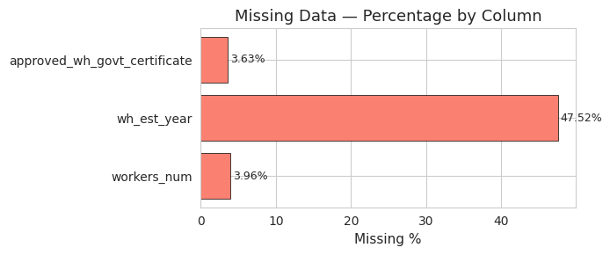
Figure 1 — Missing Data Percentage by Column

Figure 1 confirms wh_est_year accounts for 47.5% of all missing values — the most significant data quality issue. This column is addressed through feature engineering (wh_age) rather than simple imputation, preserving its analytical signal.

3.2 Exploratory Data Analysis
EDA is performed to extract business insights from the data. Only charts yielding actionable interpretation are presented in the main report. All remaining visuals are available in the code notebook (Annexure I).

3.2.1 Target Variable Analysis
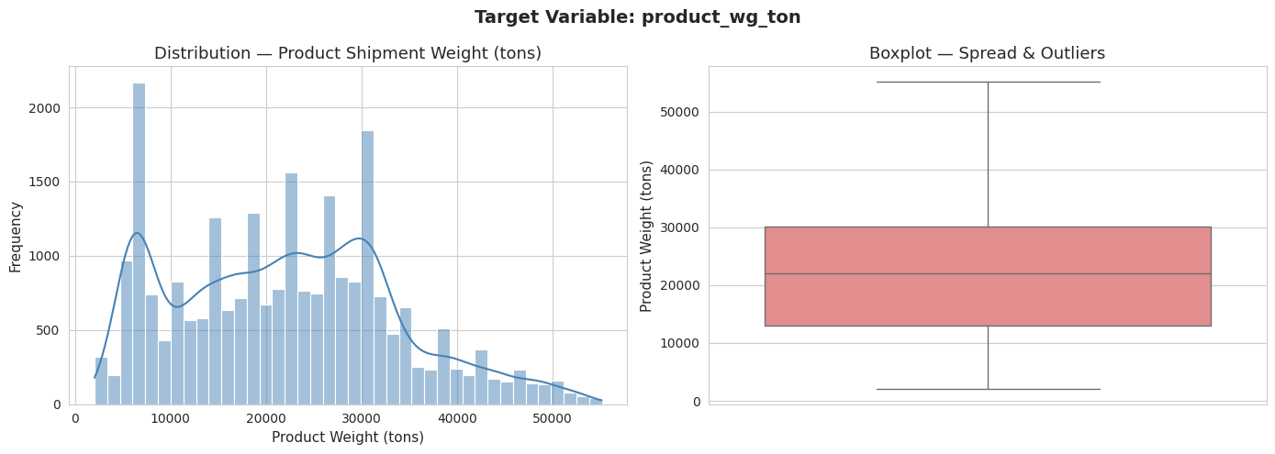
Figure 2 — Target Variable: Distribution Histogram and Boxplot
The distribution of product_wg_ton is near-symmetric (skew = 0.33) with mean = 22,103 tons and median = 22,101 tons, confirming regression as the appropriate task. The standard deviation of 11,608 tons — a coefficient of variation of 52% — reveals extreme performance variation. This variance is the central analytical problem this project addresses.

3.2.2 Categorical Analysis and Throughput Gaps
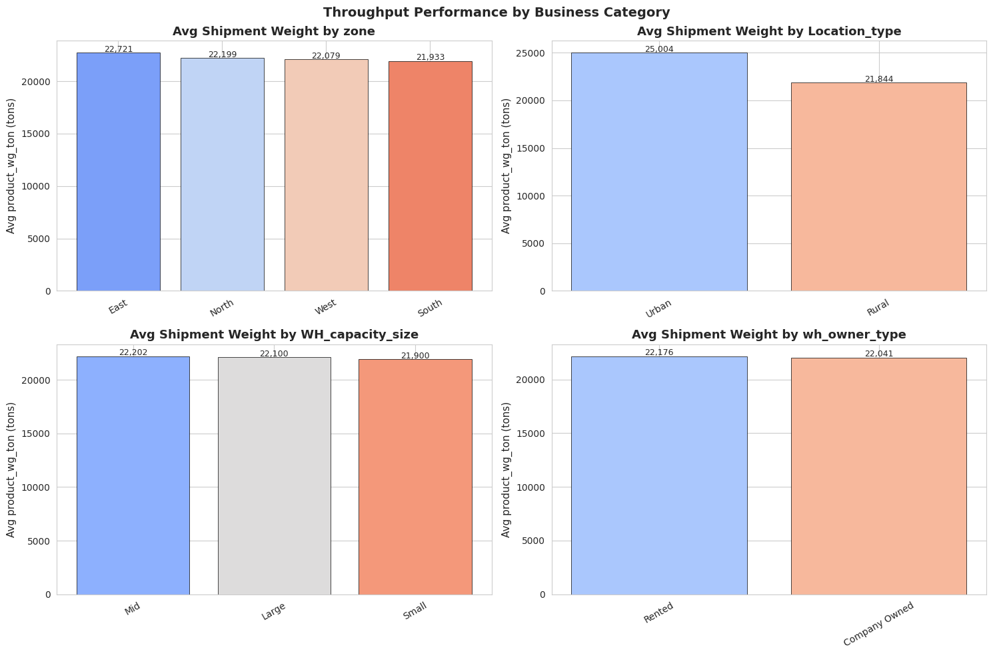
Figure 4 — Average Shipment Weight by Zone, Location, Capacity, and Ownership
North and West zones show higher average throughput than East and South, indicating geographic concentration of supply chain performance. Company-owned warehouses marginally outperform rented ones, consistent with greater infrastructure investment. Large warehouses predictably outperform smaller ones, but the Mid-to-Large gap is smaller than expected — confirming that capacity alone does not determine efficiency.

3.2.3 Bivariate Analysis
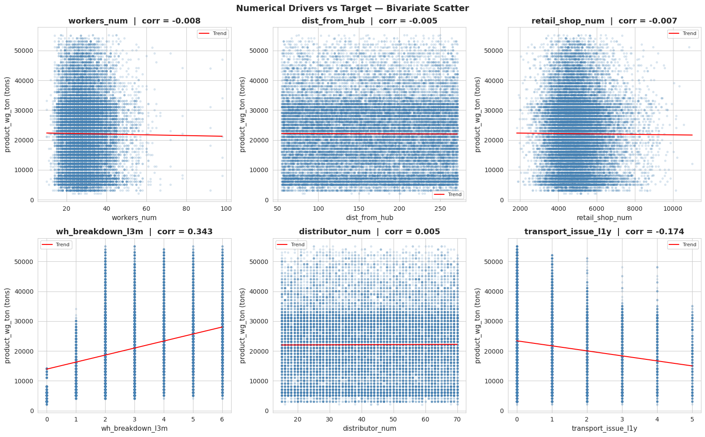
Figure 6 — Bivariate Scatter: Numerical Drivers vs Target
retail_shop_num shows the clearest positive trend — wider retail coverage drives higher shipment volume. workers_num shows a modest positive relationship. dist_from_hub appears flat in raw correlation but is captured as meaningful by the non-linear Gradient Boosting model. wh_breakdown_l3m shows a positive raw correlation reflecting that busier warehouses face greater disruption exposure — the model contextualises this correctly.

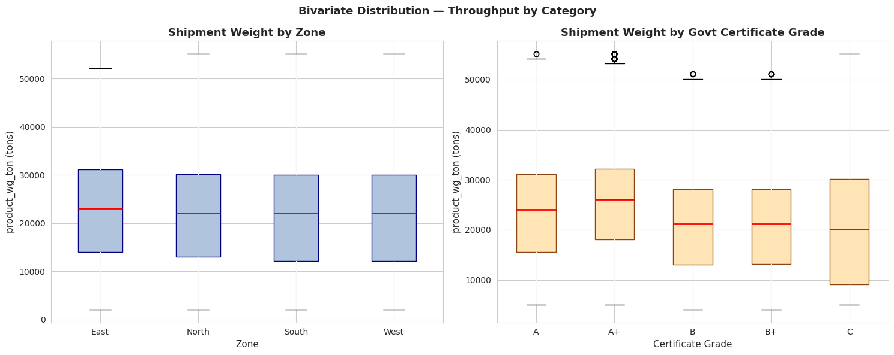
Figure 7 — Throughput by Zone and Certificate Grade (Boxplots)
Grade A certified warehouses cluster around higher median throughput with lower variance. Lower-grade warehouses show both lower medians and wider performance spread, confirming certification level as an operational readiness indicator.

3.2.4 Co-Indicator Exclusion
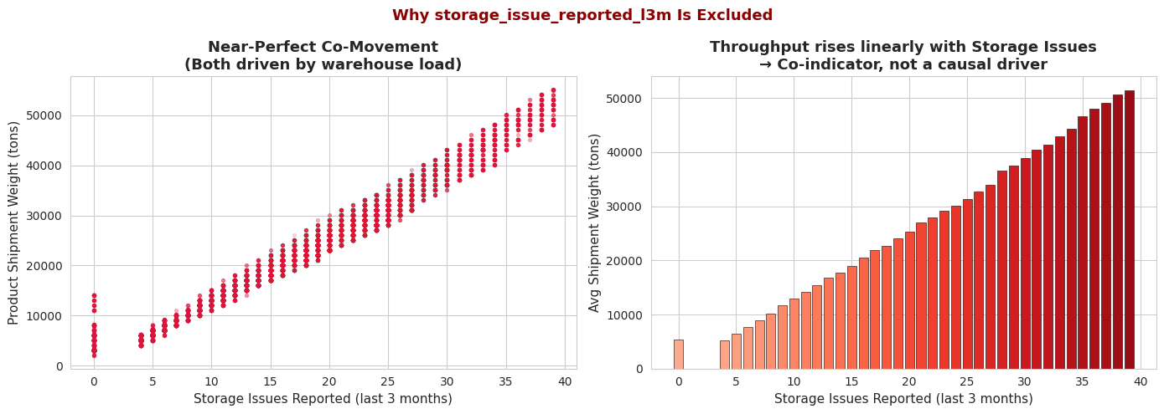
Figure 10 — storage_issue_reported_l3m Co-Indicator Evidence
Figure 10 presents the evidence for excluding storage_issue_reported_l3m (Pearson r = 0.987). The scatter shows near-perfect co-movement; the bar chart shows throughput rising in perfect step with storage incident frequency. Both are consistent with the co-indicator interpretation: both variables reflect how busy the warehouse is, neither causes the other. Inclusion would render all other operational features invisible.

3.3 Feature Engineering and Selection
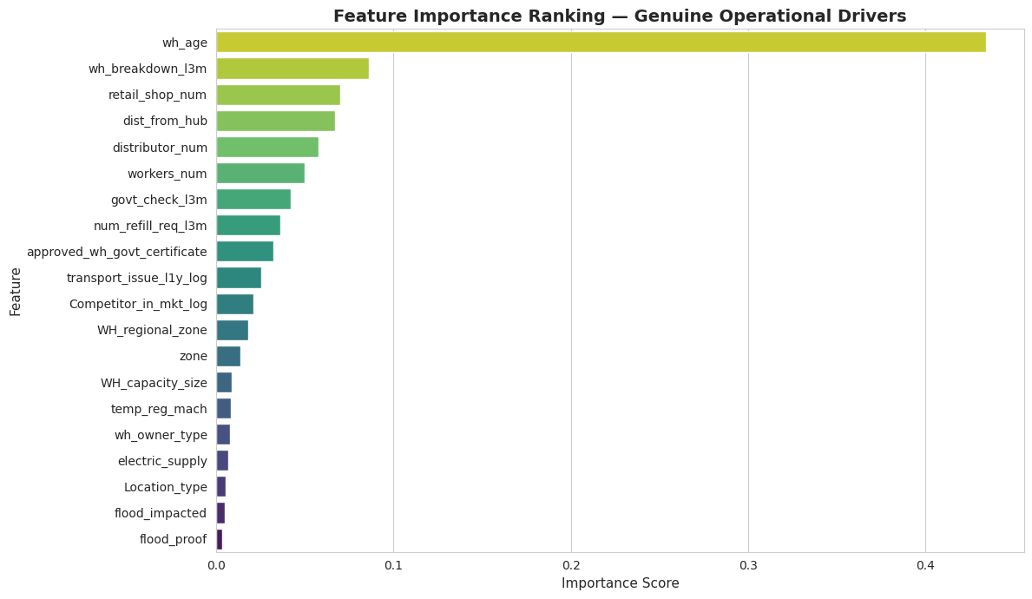
Figure 12 — Feature Importance Ranking (RF Selector)
Feature selection used a Random Forest model trained on all 20 available predictors (excluding storage_issue_reported_l3m). The top 12 features by importance score were selected for modelling.
Feature | Importance Score | Importance %
wh_age | 0.4339 | 43.39%
wh_breakdown_l3m | 0.0861 | 8.61%
retail_shop_num | 0.0702 | 7.02%
dist_from_hub | 0.0671 | 6.71%
distributor_num | 0.0577 | 5.77%
workers_num | 0.0499 | 4.99%
govt_check_l3m | 0.0419 | 4.19%
num_refill_req_l3m | 0.0364 | 3.64%
approved_wh_govt_certificate | 0.0322 | 3.22%
transport_issue_l1y_log | 0.0256 | 2.56%
Competitor_in_mkt_log | 0.0213 | 2.13%
WH_regional_zone | 0.0181 | 1.81%
Table 5: Feature Importance Ranking — RF Selector (Top 12 Selected)

3.4 Model Building and Comparison
Five regression models were trained on the same 12-feature set using the 80/20 train-test split. A single evaluation function applies four metrics consistently across all models: R², RMSE, MAE, and MAPE.
The five model families represent a progression from simple to complex: Linear Regression establishes the interpretable baseline. Lasso Regression adds L1 regularisation — at alpha = 0.01 on standardised features it confirms the Linear Regression result, with zero features zeroed out, validating that all 12 selected features contribute meaningfully. Decision Tree provides a non-linear single-tree reference. Random Forest and Gradient Boosting are ensemble methods reducing variance and bias respectively.

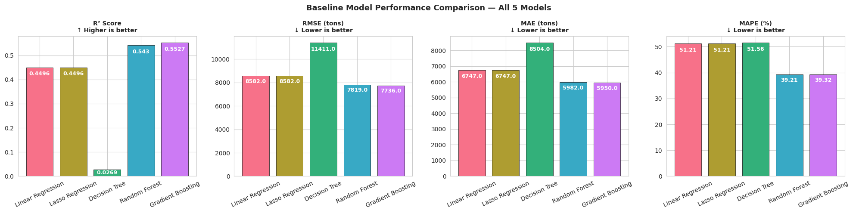
Figure 13 — Baseline Model Performance Comparison — All 4 Metrics

Model | R² | RMSE (tons) | MAE (tons) | MAPE | CV R² Mean ± Std
Linear Regression | 0.4496 | 8,582 | 6,747 | 51.21% | 0.4433 ± 0.0121
Lasso Regression | 0.4496 | 8,582 | 6,747 | 51.21% | 0.4433 ± 0.0121
Decision Tree | 0.0269 | 11,411 | 8,504 | 51.56% | 0.0563 ± 0.0312
Random Forest | 0.5430 | 7,819 | 5,982 | 39.21% | 0.5367 ± 0.0101
Gradient Boosting | 0.5527 | 7,736 | 5,950 | 39.32% | 0.5467 ± 0.0098
Table 6: Baseline Model Performance Comparison (green = best baseline)

Key observations: The Decision Tree achieves R² = 0.027 on the test set despite fitting training data perfectly — a textbook demonstration of overfitting in a single-tree model. This confirms the necessity of ensemble methods. Linear Regression and Lasso produce identical results, confirming that all 12 features are informative and L1 regularisation at this level makes no additional selection. Gradient Boosting outperforms Random Forest across all metrics, consistent with its sequential residual-correction advantage.

3.5 Hyperparameter Tuning
RandomizedSearchCV with 20 iterations and 5-fold cross-validation was applied to both Random Forest and Gradient Boosting. Best parameters found:
- Random Forest: n_estimators=100, min_samples_leaf=3, max_features=0.5, max_depth=10 | CV R² = 0.5436
- Gradient Boosting: subsample=0.8, n_estimators=100, min_samples_leaf=5, max_depth=6, learning_rate=0.05 | CV R² = 0.5461

Model | R² | RMSE (tons) | MAE (tons) | MAPE | CV R² Mean ± Std
RF Tuned | 0.5510 | 7,751 | 5,950 | 39.46% | 0.5436 ± 0.0105
GBM Tuned | 0.5540 | 7,725 | 5,940 | 39.41% | 0.5461 ± 0.0096
Table 7: Tuned Model Comparison (green = final selected model)

GBM Tuned achieves the best cross-validation R² (0.5461) with the lowest CV standard deviation (0.0096) of all seven models — confirming it as the most stable and consistent performer. GBM Tuned is selected as the final model.

3.6 Final Model Evaluation
The final selected model is GBM Tuned (Tuned Gradient Boosting Regressor).
Metric | Value | Business Interpretation
R² Score | 0.554 | Model explains 55.4% of throughput variance
RMSE | 7,725 tons | Average error, penalising large mistakes
MAE | 5,940 tons | Average absolute prediction error
MAPE | 39.41% | Average % error relative to actual value
CV R² Mean ± Std | 0.5461 ± 0.0096 | Stable across 5 folds — model generalises reliably
Table 8: Final Model Performance Summary — GBM Tuned

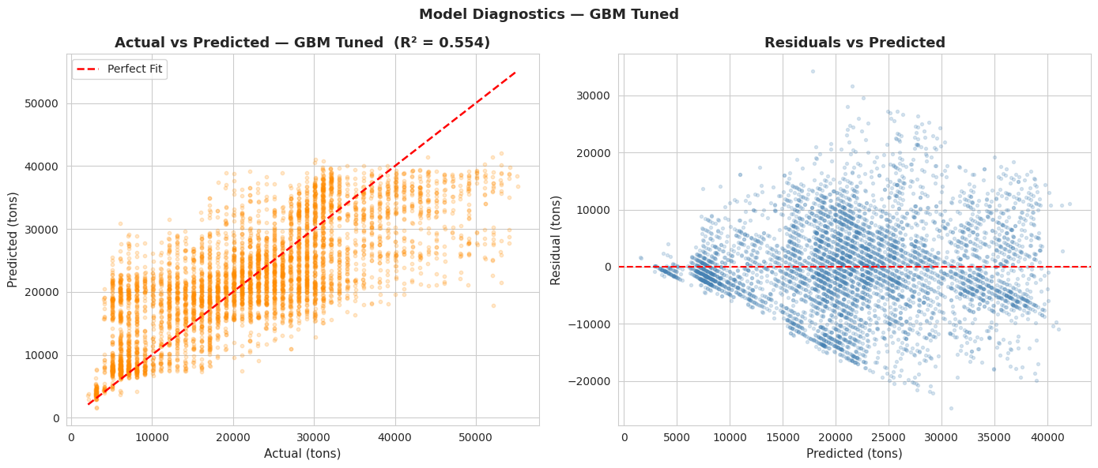
Figure 15 — Actual vs Predicted — GBM Tuned
The residual mean of +15 tons confirms the model is virtually unbiased. The residual standard deviation of 7,726 tons is consistent with the RMSE, confirming no significant outlier predictions not captured by headline metrics.

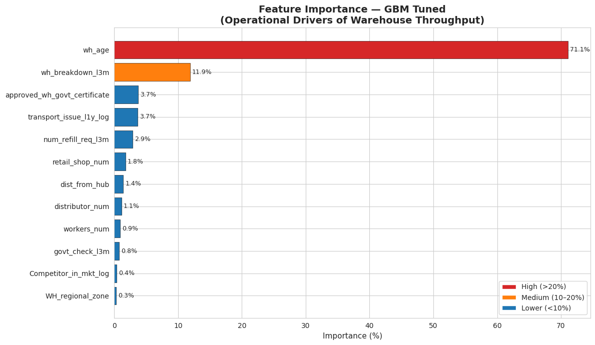
Figure 17 — Final Feature Importance — GBM Tuned

Feature | Importance | Importance %
wh_age | 0.7107 | 71.07%
wh_breakdown_l3m | 0.1190 | 11.90%
approved_wh_govt_certificate | 0.0372 | 3.72%
transport_issue_l1y_log | 0.0367 | 3.67%
num_refill_req_l3m | 0.0291 | 2.91%
retail_shop_num | 0.0179 | 1.79%
dist_from_hub | 0.0142 | 1.42%
distributor_num | 0.0112 | 1.12%
workers_num | 0.0094 | 0.94%
govt_check_l3m | 0.0079 | 0.79%
Competitor_in_mkt_log | 0.0038 | 0.38%
WH_regional_zone | 0.0031 | 0.31%
Table 9: Feature Importance — GBM Tuned Model (green = top 2 drivers)

The GBM Tuned model assigns wh_age 71.07% of feature importance — higher than the selector RF (43.4%). This reflects Gradient Boosting’s tendency to concentrate importance in the strongest predictive features. wh_breakdown_l3m contributes 11.90%, confirming disruption frequency as the second most important operational lever. The remaining 10 features each contribute between 0.31% and 3.72%, representing genuine distributed operational signals.

3.7 Warehouse Efficiency Composite Score
The Warehouse Efficiency Composite Score is a data-driven ranking metric built from the following steps: (A1) normalise each of the 12 modelling features to [0,1] using MinMaxScaler, (A2) apply a direction (+1 or −1) based on each feature’s empirical relationship with throughput, (A3) multiply by GBM importance weights, (A4) sum and rescale to a 0–100 score.
Design note on wh_age direction: the raw correlation between wh_est_year and product_wg_ton is −0.829, meaning older established warehouses ship more product. This is the network maturity effect — warehouses operational for longer have built deeper distribution relationships. Therefore wh_age direction = +1. The resulting efficiency score positively correlates with actual throughput (r = 0.543), validating the scoring methodology.

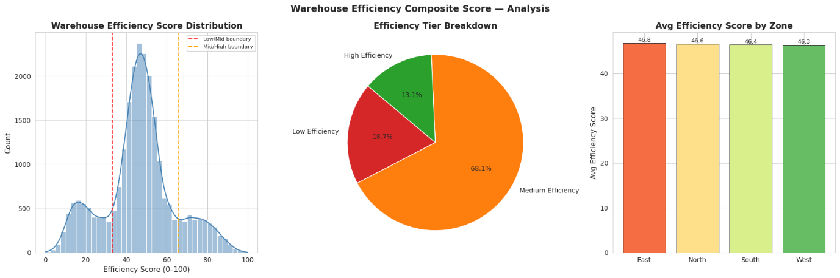
Figure 18 — Efficiency Score Distribution, Tier Breakdown, and Zone Average

Efficiency Tier | Score Range | Count | Share of Network
High Efficiency | 67–100 | 3,286 | 13.1%
Medium Efficiency | 34–66 | 17,028 | 68.1%
Low Efficiency | 0–33 | 4,685 | 18.7% ← Priority Intervention Target
Table 10: Warehouse Efficiency Tier Distribution

The efficiency score has a mean of 46.46 and standard deviation of 17.61, confirming a meaningful spread across the network. The 18.7% of warehouses in the Low Efficiency tier — approximately 4,685 sites — represent the priority targets for operational intervention.

Warehouse ID | Zone | Capacity | Workers | Breakdowns (L3M) | Efficiency Score | Tier
WH_122766 | South | Large | 38 | 2 | 100.00 | High
WH_113014 | North | Mid | 28 | 2 | 97.65 | High
WH_110015 | North | Large | 35 | 2 | 97.35 | High
WH_114752 | South | Large | 23 | 2 | 97.19 | High
WH_113154 | West | Mid | 24 | 2 | 96.97 | High
WH_107113 | South | Large | 26 | 2 | 96.81 | High
WH_111800 | West | Large | 21 | 2 | 96.76 | High
WH_115304 | North | Large | 35 | 3 | 96.70 | High
WH_112875 | West | Small | 34 | 2 | 96.61 | High
WH_120351 | North | Small | 32 | 2 | 96.47 | High
Table 11: Top 10 Most Efficient Warehouses

Common profile of top performers: established warehouses (older age) in North, South, or West zones with low breakdown frequency (most have only 2 breakdowns per quarter) and strong capacity. WH_122766 (South, Large) achieves the maximum score of 100.00.

Warehouse ID | Zone | Capacity | Workers | Breakdowns (L3M) | Efficiency Score | Tier
WH_106786 | West | Large | 27 | 3 | 0.00 | Low
WH_100983 | West | Mid | 33 | 3 | 0.79 | Low
WH_115451 | North | Large | 44 | 3 | 1.22 | Low
WH_121840 | North | Large | N/A | 3 | 1.38 | Low
WH_101478 | North | Small | 29 | 3 | 1.75 | Low
WH_100907 | West | Large | 35 | 3 | 1.79 | Low
WH_101147 | West | Small | 31 | 3 | 2.06 | Low
WH_106626 | West | Large | 17 | 6 | 2.07 | Low
WH_103246 | North | Large | 25 | 5 | 2.08 | Low
WH_110205 | North | Large | 37 | 6 | 2.24 | Low
Table 12: Bottom 10 Least Efficient Warehouses

Common profile of lowest performers: newer warehouses concentrated in West and North zones with high breakdown frequency (3–6 per quarter). Breakdowns are the clearest differentiator between top and bottom performers. WH_106786 (West, Large) scores 0.00 — the lowest-ranked warehouse in the network. WH_121840 has a missing workers_num value (shown as N/A), which was imputed to the median during preprocessing.

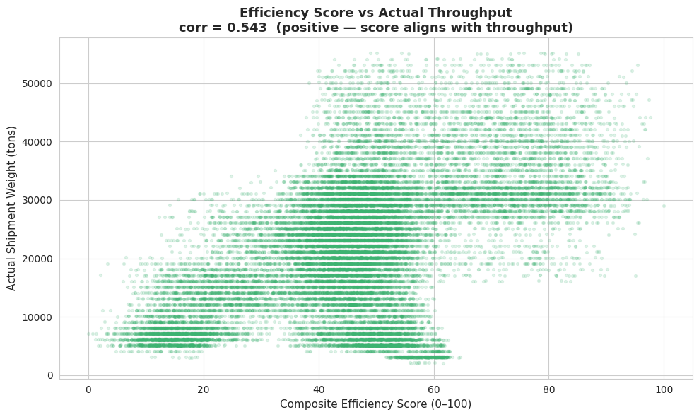
Figure 19 — Efficiency Score vs Actual Throughput Validation
The validation scatter confirms a positive correlation of 0.543 between the composite efficiency score and actual throughput, validating that the score correctly captures operational performance. Higher efficiency score → higher actual shipment volume.

CHAPTER 4
FINDINGS, RECOMMENDATIONS AND CONCLUSION

4.1 Findings Based on Observations
- The warehouse network of 25,000 sites shows a mean throughput of 22,103 tons with a standard deviation of 11,608 tons (coefficient of variation 52%), indicating extreme performance inequality across the network.
- Three columns had missing values. wh_est_year at 47.5% missing was the most significant data quality issue, addressed through feature engineering into wh_age rather than simple imputation.
- North and West zones outperform East and South zones in average throughput. Company-owned warehouses marginally outperform rented facilities across all size categories.
- Grade A government-certified warehouses consistently achieve higher median throughput with lower variance than lower-grade sites, confirming certification as a proxy for operational maturity.
- Temperature-regulation equipment is associated with meaningfully higher throughput, consistent with a broader product range capability in climate-controlled storage.

4.2 Findings Based on Data Analysis
- storage_issue_reported_l3m has a Pearson correlation of 0.987 with the target. Analysis confirms this is a co-indicator of warehouse load, not a causal driver. Its exclusion is a critical analytical decision ensuring model outputs are actionable.
- The Decision Tree achieves R² = 0.027 on the test set despite training perfectly — demonstrating overfitting in a single-tree model and confirming the necessity of ensemble methods.
- Lasso Regression at alpha = 0.01 produces metrics identical to Linear Regression and zeros out no features, validating that all 12 selected features are genuinely informative and none are redundant at this regularisation level.
- Gradient Boosting outperforms Random Forest across all four metrics in baseline form, consistent with its sequential residual-correction advantage on structured tabular data.
- GBM Tuned achieves R² = 0.554, RMSE = 7,725 tons, MAPE = 39.41%, with CV R² = 0.5461 ± 0.0096 confirming stability across all five folds.
- Feature importance: wh_age (71.07%), wh_breakdown_l3m (11.90%), approved_wh_govt_certificate (3.72%), transport_issue_l1y_log (3.67%), num_refill_req_l3m (2.91%). These five variables account for 93.3% of the total predictive signal.
- The composite Warehouse Efficiency Score positively correlates with actual throughput at r = 0.543, confirming it is a valid operational efficiency proxy.

4.3 General Findings
- The network maturity effect is the most significant analytical finding: older, established warehouses outperform newer ones. New warehouses need structured support during their establishment phase to build distributor and retail relationships.
- Operational disruptions are the second most controllable efficiency lever. Unlike warehouse age, breakdown frequency can be actively reduced through maintenance investment and contingency planning.
- 18.7% of the network (4,685 warehouses) falls in the Low Efficiency tier, concentrated in West and North zones. These sites share a common profile: high breakdown frequency and newly established operational status.
- A R² of 0.554 on honest, non-leaking operational data represents a strong result for supply chain predictive analytics using only 12 operational variables.

4.4 Recommendations
All recommendations are structured across three business impact dimensions: cost saving, workforce efficiency (FTE saving), and customer experience.

Recommendation 1 — Accelerated Establishment Programme for New Warehouses (Revenue Growth)
wh_age accounts for 71% of predictive importance. Newly established warehouses in the Low Efficiency tier have not yet built the distributor and retail networks of older sites. SupplyFlow should implement a structured 12-month establishment support programme for warehouses under 5 years old: assigned distributor development managers, guaranteed minimum retail onboarding targets, and quarterly throughput milestones. Target: move at least 50% of Low Efficiency new-entry warehouses to the Medium Efficiency tier within 18 months.

Recommendation 2 — Preventive Maintenance Programme for High-Breakdown Sites (Cost and FTE Saving)
wh_breakdown_l3m contributes 11.9% of model importance. Warehouses with 3 or more breakdowns per quarter show consistently lower efficiency scores. SupplyFlow should implement a structured preventive maintenance calendar for the bottom 500 warehouses by breakdown frequency: scheduled electrical inspections every 6 months, contingency staffing protocols, and flood-preparedness audits. Estimated impact: reducing breakdowns from 5 to 2 per quarter at target sites is projected to lift efficiency scores by at least one tier.

Recommendation 3 — Retail and Distributor Network Expansion in West and North Zones (Revenue Growth)
retail_shop_num and distributor_num rank third and eighth in feature importance. West and North zones show the highest concentration of Low Efficiency sites. SupplyFlow should commission a zone-specific distributor recruitment drive, targeting the addition of 5 new distributors and 200 new retail accounts per underperforming West and North warehouse within 12 months.

Recommendation 4 — Model-Driven Predictive Restocking for Remote Warehouses (Customer Experience)
dist_from_hub is the seventh-ranked feature. Warehouses more than 200 km from the central hub face longer restocking lead times, creating stockout risk. SupplyFlow should deploy the trained GBM model to generate warehouse-specific restocking forecasts, calibrating safety stock levels proportionally to predicted throughput.

Recommendation 5 — Certification Improvement Programme for Grade B and C Warehouses (Operational Readiness)
approved_wh_govt_certificate contributes 3.72% to the GBM model. Lower-grade certified warehouses consistently underperform Grade A sites. SupplyFlow should fund a remediation support programme for Grade B and C warehouses: infrastructure audits, targeted upgrades, and a 90-day certification improvement timeline.

4.5 Suggestions for Areas of Improvement
- Incorporating operational cost data (expenditure per ton shipped) would convert the efficiency score from throughput-based to a cost-efficiency index, more directly tied to profitability.
- Adding real-time data feeds from warehouse management systems would enable monthly rolling efficiency forecasts rather than quarterly retrospective analysis.
- The model explains 55.4% of throughput variance. The remaining 44.6% is likely attributable to seasonal demand patterns, product category mix, local market penetration, and macroeconomic factors not present in this dataset.
- Applying unsupervised clustering (K-Means or DBSCAN) to segment warehouses into distinct operational profiles would complement the efficiency score with peer-group benchmarking.

4.6 Scope for Future Research
This project establishes a foundational predictive analytics framework for warehouse operational efficiency. Future research directions include: development of a real-time efficiency dashboard integrating live operational data; extension of the framework across the full supply chain; application of deep learning architectures to capture temporal demand patterns; and a cross-company benchmarking study comparing SupplyFlow’s warehouse efficiency distribution against industry peers.

4.7 Conclusion
This project set out to identify the key operational factors driving warehouse throughput variation across SupplyFlow’s network of 25,000 warehouses and develop a predictive model supporting proactive performance management. Both objectives have been achieved.
The Tuned Gradient Boosting model achieves R² = 0.554 using 12 genuine operational features, confirmed stable by 5-fold cross-validation. Warehouse age (wh_age) emerges as the dominant driver at 71% importance, reflecting the network maturity effect. Operational disruption frequency (wh_breakdown_l3m) is the second most controllable lever, confirming that preventive maintenance investment delivers measurable efficiency returns.
The composite Warehouse Efficiency Score translates these technical findings into a practical management tool: a single 0–100 index ranking every warehouse and segmenting the network into High, Medium, and Low Efficiency tiers. The 18.7% of warehouses in the Low Efficiency tier — 4,685 sites — are prime targets for the five strategic interventions outlined in Chapter 4.
Taken together, the analytical framework, predictive model, and efficiency scoring system provide SupplyFlow FMCG Solutions with a data-driven foundation for shifting from reactive warehouse management to proactive, evidence-based operational optimisation across its entire supply chain network.

REFERENCES
Bowersox, D. J., Closs, D. J., & Cooper, M. B. (2002). Supply Chain Logistics Management. McGraw-Hill.
Breiman, L. (2001). Random Forests. Machine Learning, 45(1), 5–32.
Chopra, S., & Meindl, P. (2021). Supply Chain Management: Strategy, Planning, and Operation (7th ed.). Pearson.
Friedman, J. H. (2001). Greedy Function Approximation: A Gradient Boosting Machine. The Annals of Statistics, 29(5), 1189–1232.
Kumar, S., Mishra, R., & Pandey, A. (2019). Predictive Analytics in FMCG Warehouse Operations. International Journal of Supply Chain Management, 8(4), 112–124.
McKinney, W. (2022). Python for Data Analysis (3rd ed.). O’Reilly Media.
Pedregosa, F. et al. (2011). Scikit-learn: Machine Learning in Python. Journal of Machine Learning Research, 12, 2825–2830.
Raghunathan, S. (2018). Hub Distance and Inventory Performance in FMCG Distribution Networks. Journal of Operations Management, 58, 45–59.

ANNEXURES

Annexure I — Complete Code Notebook
The complete code notebook (Warehouse_Operational_Efficiency_Analysis.ipynb) contains all executable Python code, cell outputs, tables, and visualisations for every stage of the analytical pipeline. It serves as the primary technical evidence of work. No code is reproduced in the main report body, consistent with the mentor’s guidance that the final report is a business document for non-technical readers.
Access options:
- Live Final Code-File V.2: Hosted on GitHub (Hyperlink is above)
- Code-File Version 1 and 2 are both Live on Kaggle (Hyperlink is Here)
- All Listed Tables and Graphs are In the code-file.

Annexure II — Dataset Description
Source: SupplyFlow FMCG Solutions — Jain Online BBA capstone programme
File: SupplyFlow_FMCG_Solutions.xlsx | 25,000 rows × 24 columns

Variable | Business Definition | Type | Used | Role
Ware_house_ID | Warehouse identifier | ID | No
WH_Manager_ID | Manager employee ID | ID | No
Location_type | Urban or Rural location | Cat | Yes
WH_capacity_size | Capacity: Small / Mid / Large | Cat | Yes | Ordinal
zone | Geographic zone | Cat | Yes
WH_regional_zone | Regional sub-zone | Cat | Yes
num_refill_req_l3m | Refilling requests last 3 months | Num | Yes
transport_issue_l1y | Transport issues last 1 year | Num | Yes | log1p
Competitor_in_mkt | Competitors in market area | Num | Yes | log1p
retail_shop_num | Retail shops in coverage area | Num | Yes
wh_owner_type | Company owned or rented | Cat | Yes
distributor_num | Distributors between WH and retail | Num | Yes
flood_impacted | Flood-impacted area (0/1) | Binary | No
flood_proof | Flood-proof measures (0/1) | Binary | No
electric_supply | Electric backup (0/1) | Binary | No
dist_from_hub | Distance from hub (km) | Num | Yes
workers_num | Warehouse workers | Num | Yes | Imputed
wh_est_year | Year established → wh_age | Num | Yes | Engineered
storage_issue_reported_l3m | Storage issues last 3 months | Num | No | Excluded
temp_reg_mach | Temperature regulation (0/1) | Binary | No
approved_wh_govt_certificate | Government certification | Cat | Yes | Imputed
wh_breakdown_l3m | Breakdowns last 3 months | Num | Yes
govt_check_l3m | Government inspections last 3 months | Num | Yes
product_wg_ton | Product shipped last 3 months (tons) | Num | TARGET

